**Scientific Method**

**I: Overview of the Scientific Method**

The scientific method is a process for experimentation that is used to explore observations and answer questions. Scientists use the scientific method to search for **cause and effect** relationships in nature. In other words, they design an experiment so that changes to one item cause something else to vary in a predictable way.

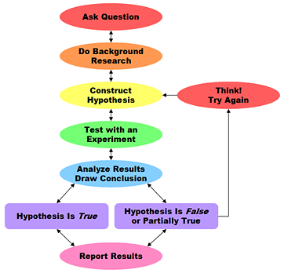

**II: Traditional Steps of the Scientific Method**

**A: Observation- something is observed or questioned?**

**B: Hypothesis- “educated Guess” a hypothesis is tentative and testable statements that must be capable of being supported or not supported by observational evidence.**

**C: Experiments- test the hypothesis in various ways. An experiment must have a control and a testable variable. You can only change one variable at a time.**

**D: Theory- A hypothesis that has been tested over a wide variety of conditions are incorporated into scientific theories; when new evidence is found theories can be changed of modified. Theories are based on natural and physical phenomena and care capable of being tested by a number of researchers.**

**E: Scientific Law- Theories that have stood up to repeated and exhaustive testing are classified as a scientific law. This type of law you cannot break!**